- INTRODUCTION
Medical Report Generator is an android application and it is also called as pathology reporting software. This Software is the easiest for Pathology Lab and Diagnostic Laboratories. This software gives high quality lab report printing and provides efficient management of lab records. It can make your laboratory report generation and accounts management job much simpler and quicker.
It is suitable for any kind of pathology laboratory or Diagnostic Centre. It is designed to automate the whole operations of a pathology lab or Diagnostic centre like billing, daily sample collection monitoring, pathological tests carried out, test report generation, patient information management and diagnostic reports entry, and fees collection.
Diagnosis reports include the findings of the clinical examination conducted on a patient. Every hospital has to prepare a medical report on every patient for further assessment of the patient’s condition. Furthermore, at times, the medical reports are also wanted by the courts when the patient is seeking for an injury or accident compensation claim.
In this software, has a login page which allows only the registered user to login and thereby preventing unauthorized access and only laboratory people will login to this app. This system can be used by all the patients to enter their details manually.
For login in to these system, all patients will have some same basic attributes like name, age, gender, referrer, test name. Based on the selected test name, it will redirects to the particular test details. The android mobile user will be able to track his medical reports very quickly. Usage of this application will greatly reduce time at the time of diagnosis.

This project acts as an important role in saving time of human beings and which is also its main aim. The project “Medical Report Generator” is developed so that diagnosticians can view the information about Medical Reports of various Diseases and Deficiencies such as Liver Function Test, Uric acid test, Calcium, Iron and other such along with their personal details and previous disease details.
The main aim of developing this application is to reduce the time to a great extent that is spent in keeping and maintaining records. Thus this application provides the required information in no time and also helps in quicker decision making.

3. REQUIREMENT ANALYSIS

Business Requirements
3.1 ENTRY POINT
The system is required to have two entry points:
LOGIN
The User needs to register with the application by entering all the details. The User can get login by entering valid username and password. The User can add its report by selecting correct test from drop down menu and filling respective fields.
REGISTER
The User needs to register first with the app by entering all the details. Receive can get login by entering valid username and password.
USER BENEFITS
This process has proved its advantages:
1. Better patient care.
2. Fast analysis of the huge medical data.
3. Time saved during accessing the medical information.
4. Less paperwork and better archival options.
5. Increased quality of the source data due to multiple reviews.
6. Less man-hours and cost effective.

3.2 SELECTION OF PRODUCT
System Requirements
- Windows/Linux/ Mac PC with at least i3 processor. Processor is expected to have at least 4 cores with a clock speed of above 2Ghz. But as always, the higher the better.
- 4GB is the minimum required RAM. But I suggest using 8GB.
- 1280 x 800 minimum screen resolution.
- 2–4GB of disk space. This depends on the versions of Android SDKs and system images you install. For every system emulator you create you take about 1–2GB of the disk space.
3.3 SPECIFIC REQUIREMENTS
3.3.1 Functional Requirements
- Windows 10,8(any version)
- Android Development Toolkit(ADT)
- Android Studio(IDE), Integrated Development Environment
Hardware Requirements
- Processor – i3
- Hard Disk – 5 GB
- Memory – 1GB RAM
- Android device

3.3.2 Non-Functional Requirements
- Efficiency
The efficiency of any system is concerned with the minimum processing time as well as the optimal use of system resources in designing the proposed system; the efficiency factor has been taken well into consideration.
- User-Friendly Interface
The interface will be user-friendly so that a common user can use it easily. In our, we make it very easy for the user to jump from one section to another. Another uniqueness of the design that it is based on the fluid interface, it can adjust itself according to the device in which the system is being used.
- Data Security And Management
Data security and integrity is our topmost priority. We will make sure that private data of every single user must remain confidential and never be compromised. For this purpose, we will use effective security mechanisms.
- Performance And Scalability
The system is required to scale to support transaction volume. Android apk should be light and render fast.

3.4 DESIGN TECHNIQUES
Design of the android app has been done using the following technologies: -
- Front End: Android Sdk
- Backend: SqLite
Incremental model is advisable where requirements are clear, and the development time is less. The striking feature of incremental model is that each module can be completed and released as and when requirement arises because of lack of time.
As in our system many of the modules are not inter-related so can be released in isolation. The user can thus get a feel of these modules and give his feedback which can be utilized for making the application more user friendly and in line with the user requirements.
The process model suitable is Iterative Waterfall Model.

- DESIGN

Android users expect the app to look and behave in the way that it comfortable and consistent with the platform.

4.1 USE CASE DIAGRAM

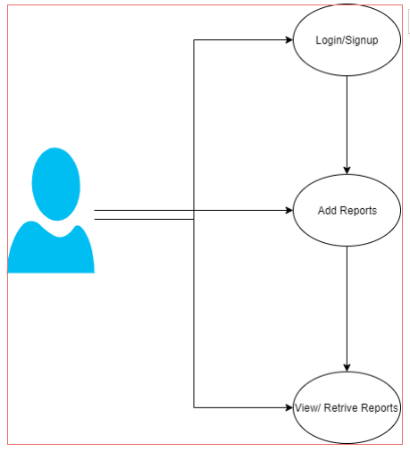

4.2 FLOW DIAGRAM

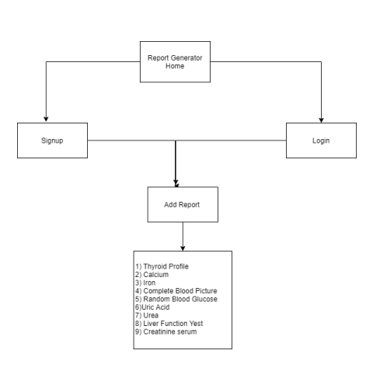

4.3 ACTIVITY DIAGRAM

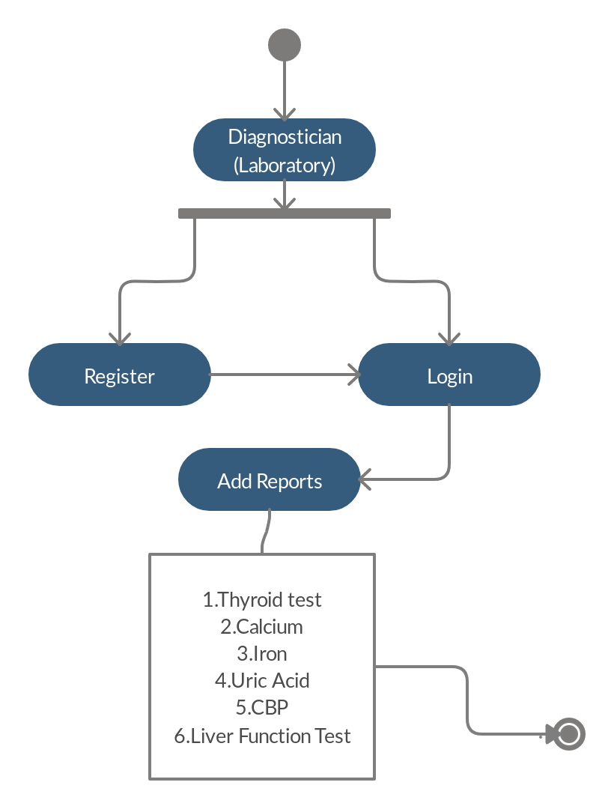

5. IMPLEMENTATION

This system app is developed by using Android SDK and Database used is SQLite.
Android is an open-sourced operating system that is used primarily on mobile devices, such as cell phones and tablets. It is a Linux kernel-based system that's been equipped with rich components that allows developers to create and run apps that can perform both basic and advanced functions. Mobile operating system that is based on a modified version of Linux. Developed by Google and later the Open Handset Alliance (OHA)Allows writing managed code in the Java language Unveiling of the Android platform was announced on 5 November 2007 with the founding of OHA.
Android has many features such as Application framework, Dalvik Virtual Machine, Integrated Browser, SQLite, Media Support, GSM Telephony, Blue tooth, EDGE, 3G, WiFi, Camera, GPS, Compass, accelerometer, rich development environment.
Google Android SDK is used for developing apps. The Google Android SDK is a toolset that developers need in order to write apps on Android enabled devices. It contains a graphical interface that emulates an Android driven handheld environment, allowing them to test and debug their codes.
To develop the android apps we require the emulators. The emulator lets developers "play" around an interface that acts as if it were an actual mobile device. They can write and test codes, and even debug. Emulators are a safe place for testing codes especially if it is in the early design phase.
Android application has some of the essential items that are present each time an Android project is created:
1. AndroidManifest.xml
2. build.xml
3. bin/
4. src/
5. res/
6. assets/
Android has many versions like
Android 8.0 Oreo
Android 7.0 – 7.1.2 Nougat
Android 6 – 6.0.1 Marshmallow
Android 5 – 5.1.1 Lollipop
Android 4.4 – 4.4.4 KitKat
Android 4.1 – 4.3 Jelly Bean
Android 4.0-4.0.4 Ice Cream Sandwich
The important core components of a android are: Activities, Intents, Services , Content Provider , Fragment
Activity are the part of the mobile application which the user can see and interact with. For Example, if you open an SMS app which has multiple activities like create new SMS, add a contact from the address book, write the content in the SMS body, send SMS to the selected contact, etc. Keeps track of what a user is currently looking for in an app. Keeps a track of previously used processes, so that the user can switch between ongoing process and previous process. It helps to kill the processes so that the user can return to their previous state An activity is implemented as a subclass of Activity class.
Service is an Android component which runs in the background and acts independently. It does not provide any user interface. Though the services are running behind the scene, a user can continue their work on different apps. Most of the time, the users are not aware of the services which are running in the background. These services allow the system to kill the process without interrupting the user’s ongoing work.
A content provider manages access to a central repository of data. A provider is part of an Android application, which often provides its own UI for working with the data. However, content providers are primarily intended to be used by other applications, which access the provider using a provider client object.
Android has an Intent class when the user has to navigate from one Activity to another. Intent displays notifications from the device to the user and then the user can respond to the notification if required. They are the two types: Implicit Intents, Explicit Intents.
Android Fragment is the part of activity, it is also known as sub-activity. There can be more than one fragment in an activity. Fragments represent multiple screen inside one activity.
Android fragment lifecycle is affected by activity lifecycle because fragments are included in activity.
Each fragment has its own life cycle methods that is affected by activity life cycle because fragments are embedded in activity.
SQLite is a self-contained, high-reliability, embedded, full-featured, public-domain, SQL database engine. It is the most used database engine in the world. It is an in-process library and its code is publicly available. It is free for use for any purpose, commercial or private. It is basically an embedded SQL database engine. Ordinary disk files can be easily read and write by SQLite because it does not have any separate server like SQL. The SQLite database file format is cross-platform so that anyone can easily copy a database between 32-bit and 64-bit systems. Due to all these features, it is a popular choice as an Application File Format.
Features of SQLite
- The transactions follow ACID properties i.e. atomicity, consistency, isolation, and durability even after system crashes and power failures.
- The configuration process is very easy, no setup or administration needed.
- All the features of SQL are implemented in it with some additional features like partial indexes, indexes on expressions, JSON, and common table expressions.
- Sometimes it is faster than the direct file system I/O.
- It supports terabyte-sized databases and gigabyte-sized strings and blobs.
- Almost all OS supports SQLite like Android, BSD, iOS, Linux, Mac, Solaris, VxWorks, and Windows (Win32, WinCE, etc. It is very much easy to port to other systems.
- Complete database can be stored in a single cross-platform disk file.

Applications of SQLite
- Due to its small code print and efficient usage of memory, it is the popular choice for the database engine in cellphones, PDAs, MP3 players, set-top boxes, and other electronic gadgets.
- It is used as an alternative for open to writing XML, JSON, CSV or some proprietary format into disk files used by the application.
- As it has no complication for configuration and easily stores file in an ordinary disk file, so it can be used as a database for small to medium sized websites.
- It is faster and accessible through a wide variety of third-party tools, so it has great application in different software platforms.
6.OUTPUTS

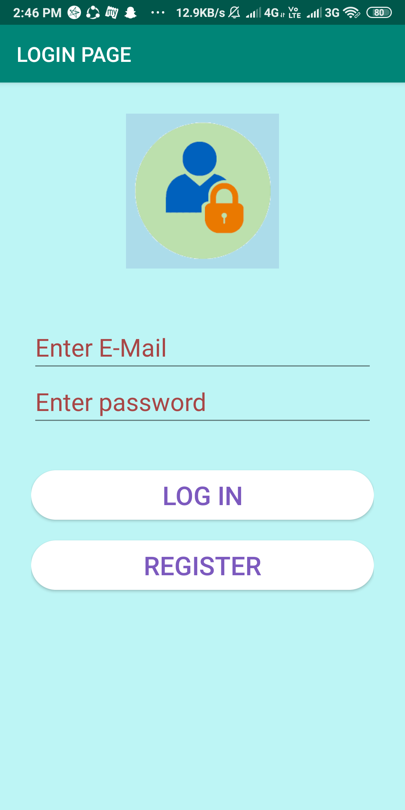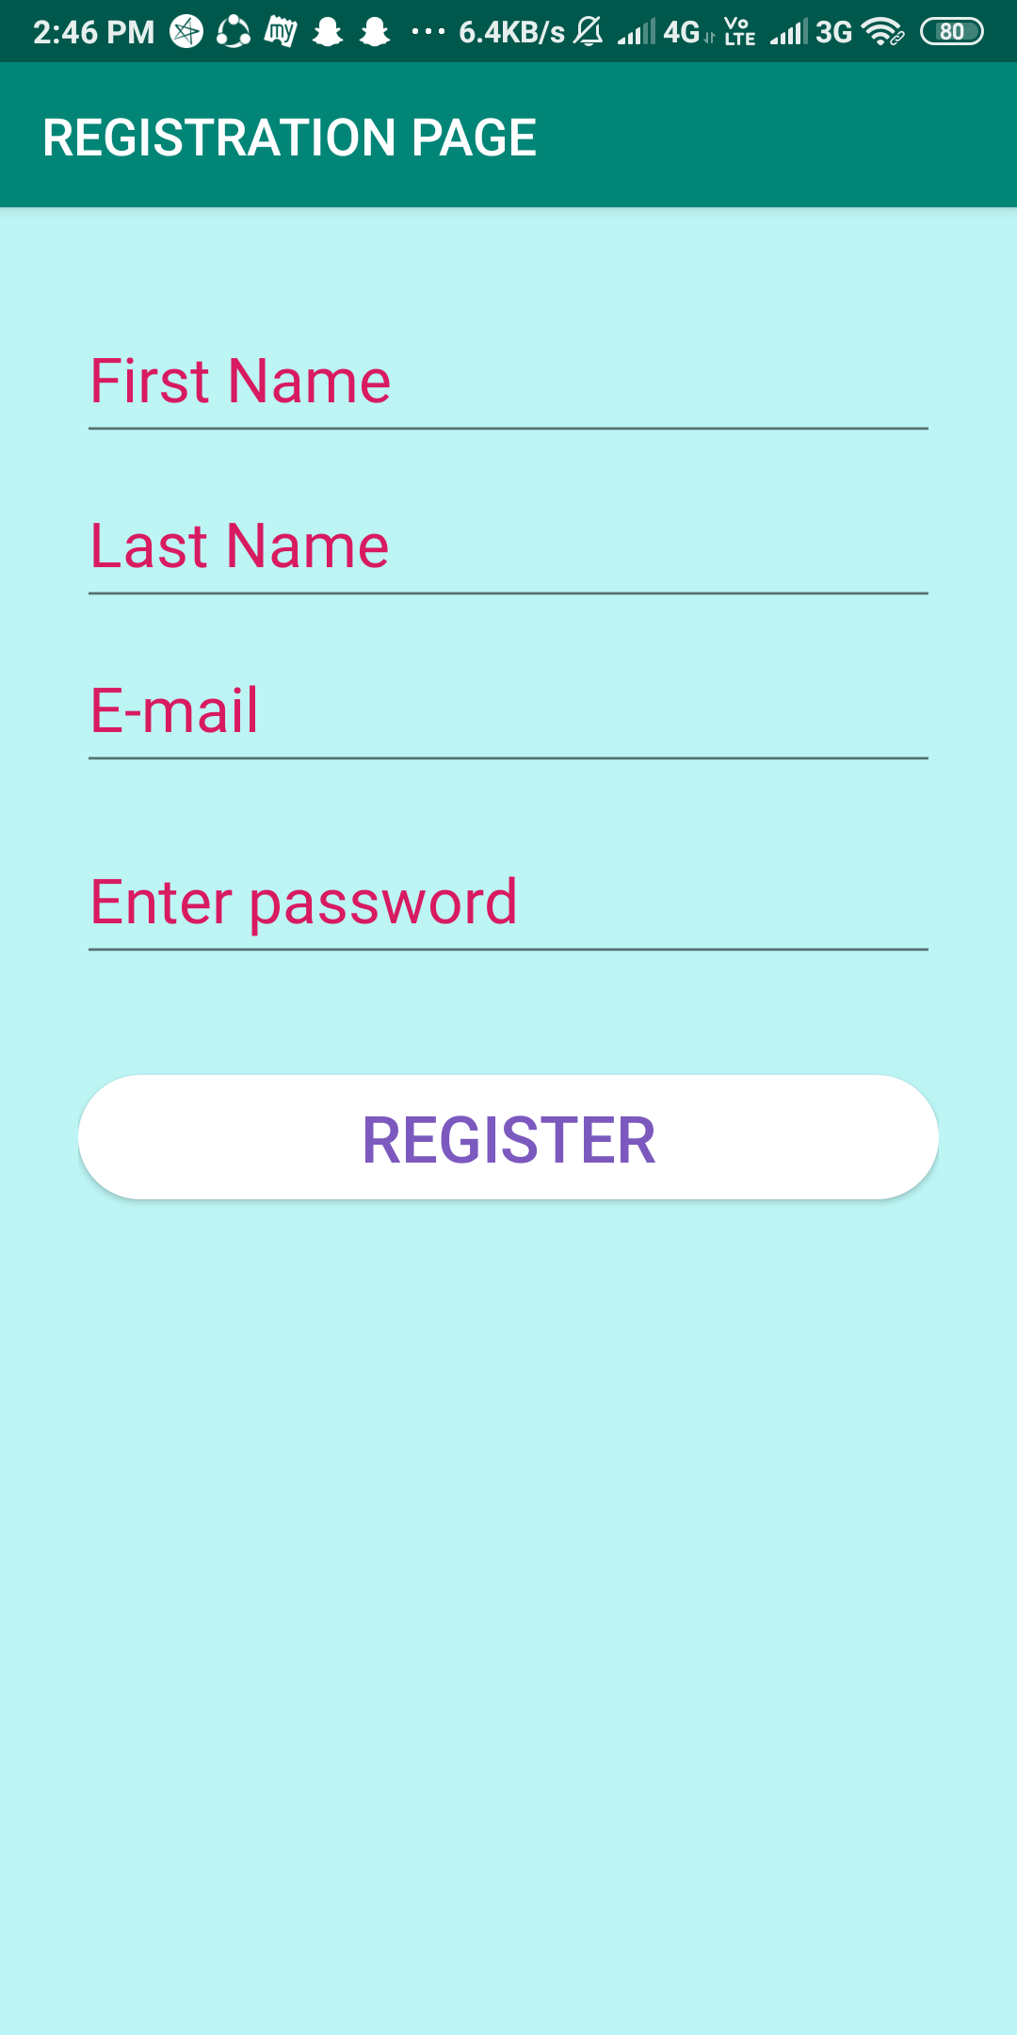
Figure 6.1 Login Page Figure 6.2 Registration Page

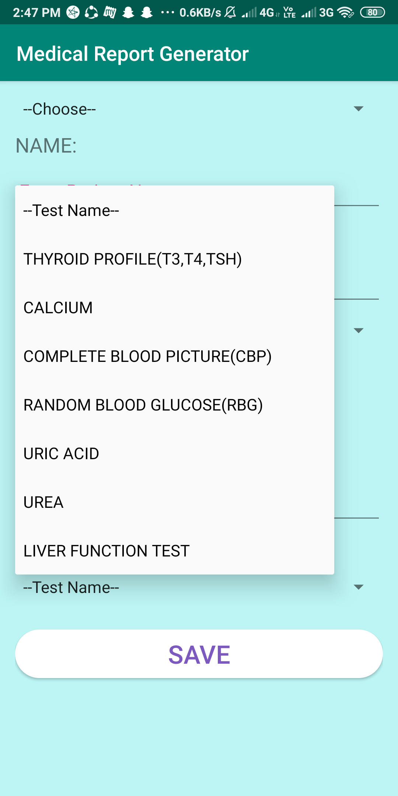

Figure 6.3 Common Fields Page

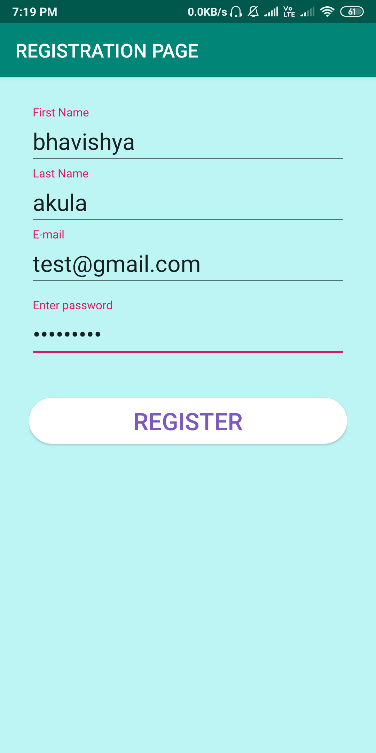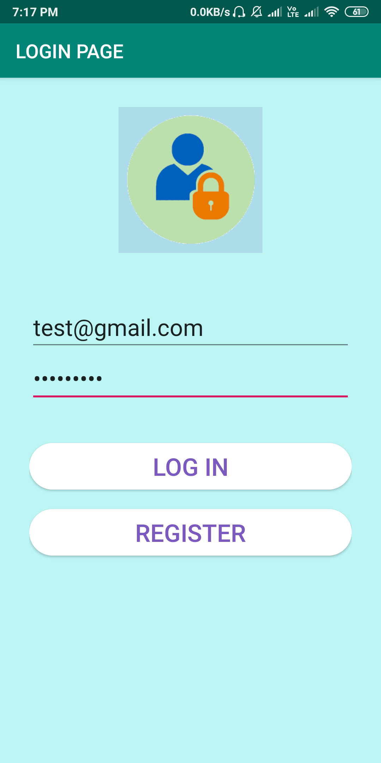

Figure 6.4 Registration Page with Details Figure 6.5 Login Page with Details

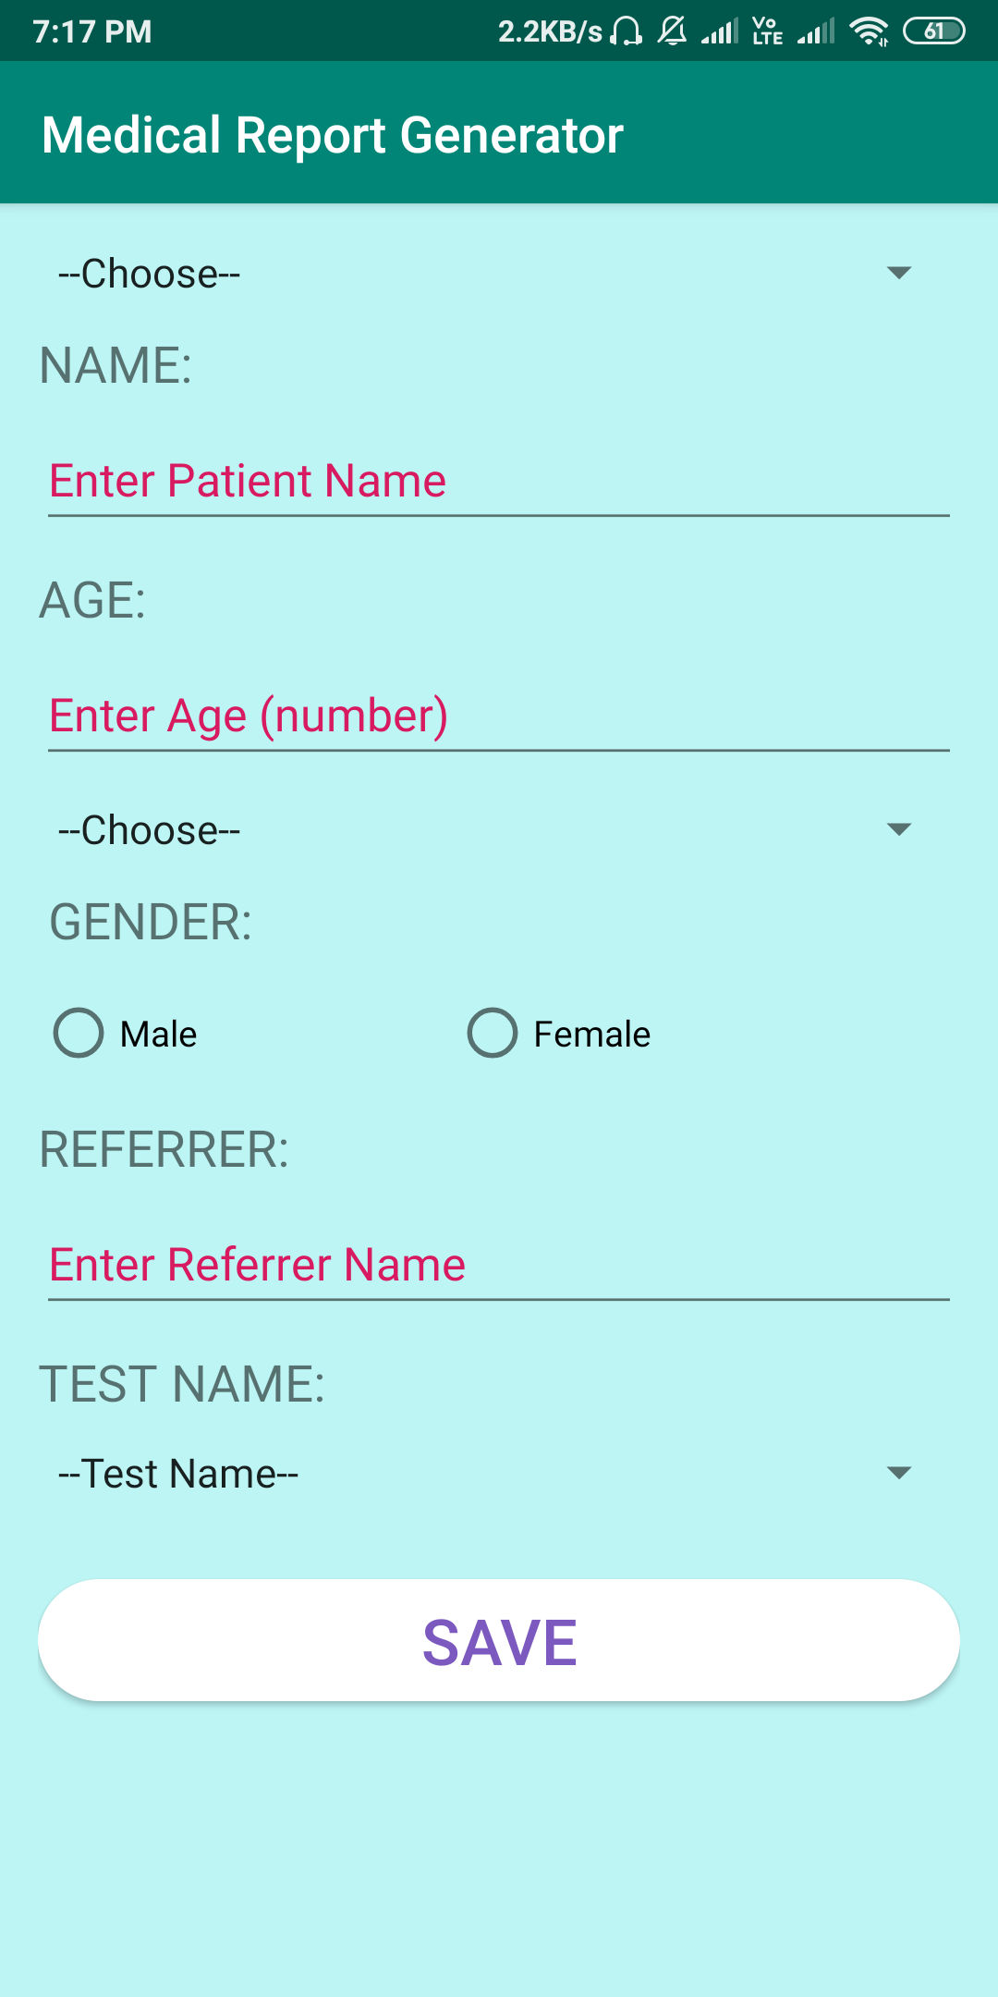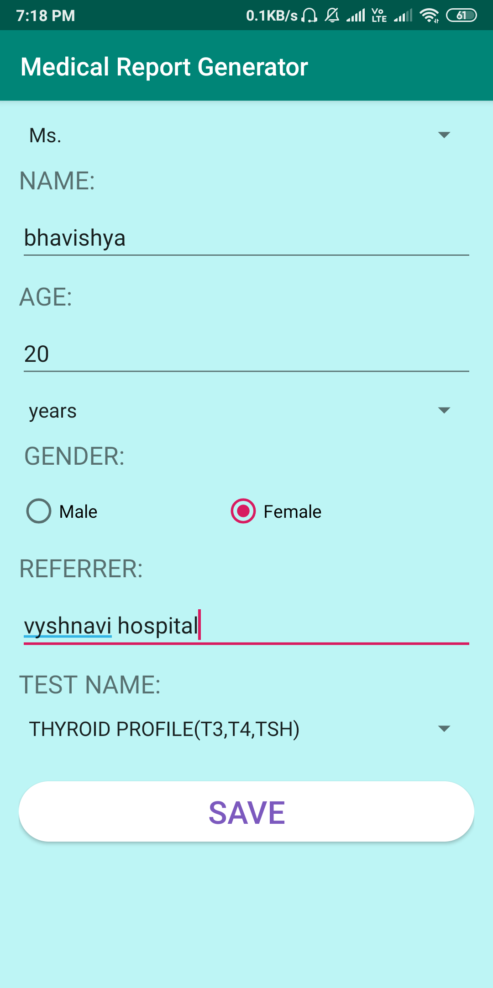

Figure 6.6 Patient Details Template Figure 6.7 Patient Details

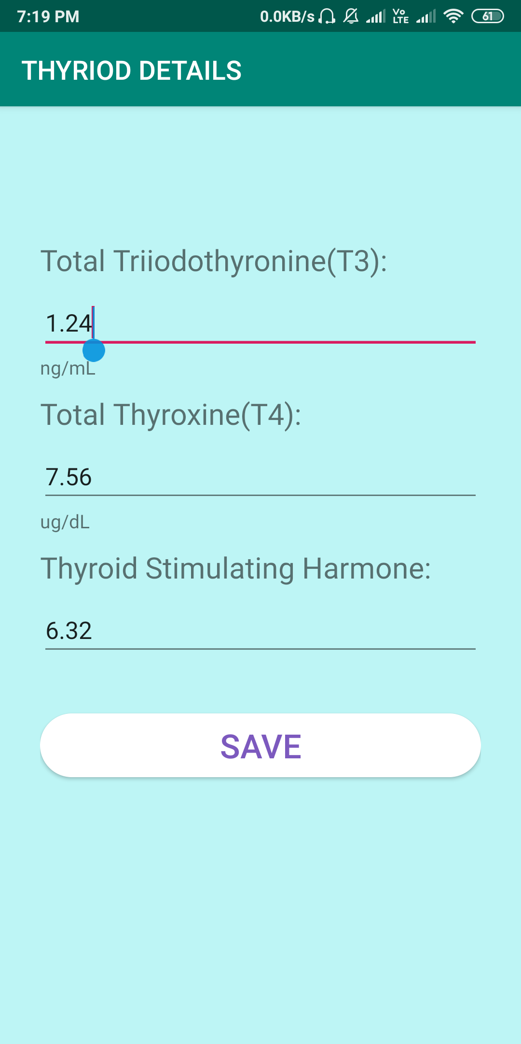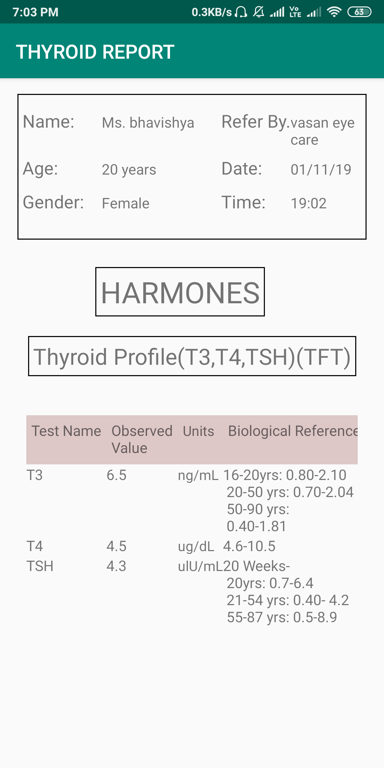

Figure 6.8 Test Details Figure 6.9 Generated Report

- ADVANTAGES & DISADVANTAGES
7.1 ADVANTAGES
- Easy to understand and implement.
- Testing in each phase.
- Documentation Available after each phase.
- Most Suitable for single projects where work products are
well defined, and their functioning is understood.
7.2 DISADVANTAGES
- Once detecting error at any face it may be required that the precede subsidy faces may change.
- Very difficult to manage changes b/w the phases there are possibility of blocking which can slow down the productivity and efficiency of the process.
- Risk is not addressed in this model.

Advantage of Model in this System
- Easy to Understand.
- It is the basic model of all models.
- Errors are detected after each Phase of Development.
- It is Single and Small Project.

8. CONCLUSION

Our project is a user-friendly, live sample of how diagnostic reports are generated by the diagnostician. Since, it is an android application, the user can work on it at their best comfort. Few credentials like login time and date are triggered in the report for an easy reference. Usage of this application will greatly reduce time at the time of diagnosis.
At the end, we would finally conclude that we have made efforts in taking the inputs from the database and generated the required medical test report based with the patient details. We have described the requirement specifications that are needed for the application. Finally, the application is implemented and tested against the testcases.

REFERENCES

[1] https://developer.android.com › studio

[2] https://www.tutorialspoint.com › android › android_studio

[3] www.cgh.com.sg

[4] https://www.javatpoint.com › android-sqlite-tutorial

[5] https://www.journaldev.com › android-sqlite-database-example-tutorial

[6] https://www.androidauthority.com › android-sdk-tutorial-beginners-634376

